PROJECT-46
AI Product Description Generator
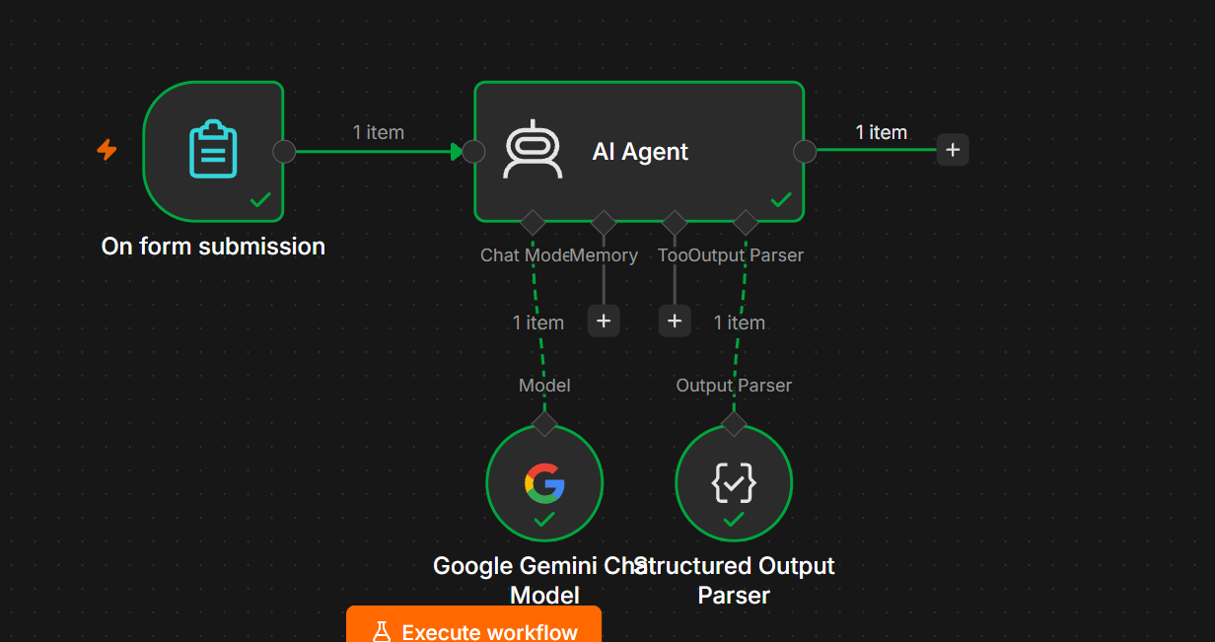
. Project Name
AI Product Description Generator
2. Objective
The AI Product Description Generator automatically creates a professional, attractive, and SEO-friendly product description from basic product information submitted through a form.
The user provides details such as:
- Product name
- Product category
- Features
- Price
- Target audience
- Product specifications
The AI analyzes the information and generates ready-to-use product content.

3. n8n Workflow
The workflow is:
On Form Submission
↓
AI Agent
↓
Output Parser
And the Gemini model is connected to the AI Agent:
Google Gemini Chat Model
↓
AI Agent
Important
No Vector Store is required.
You do not need:
- ❌ Simple Vector Store
- ❌ Data Loader
- ❌ Text Splitter
- ❌ Embeddings
Because the AI is generating content from the information submitted in the form rather than searching a knowledge base.

4. Form Fields
Create an On Form Submission node.
Add these fields:
Field | Type | Example
Product Name | Text | Wireless Bluetooth Headphones
Product Category | Text | Electronics
Product Features | Text Area | Noise cancellation, 30-hour battery
Price | Number | 2999
Target Audience | Text | Students and professionals
Product Specifications | Text Area | Bluetooth 5.3, USB-C charging
Recommended
Use Text Area for:
- Product Features
- Product Specifications
because users may enter multiple sentences.

5. AI Agent
Connect:
On Form Submission → AI Agent
The form data becomes the input to the AI Agent.
User Prompt
Use an expression-based prompt such as:
Product Name:
{{ $json["Product Name"] }}

Product Category:
{{ $json["Product Category"] }}

Product Features:
{{ $json["Product Features"] }}

Price:
{{ $json["Price"] }}

Target Audience:
{{ $json["Target Audience"] }}

Product Specifications:
{{ $json["Product Specifications"] }}

Create a professional product description based on the information above.

6. Google Gemini Chat Model
Add Google Gemini Chat Model and connect it to the Chat Model input of the AI Agent.
The connection should look like:
Google Gemini
│
▼
On Form Submission → AI Agent
You can use the Gemini credential you already configured.

7. System Message
In the AI Agent's System Message, use:
You are an AI Product Description Generator.

Your job is to create professional, attractive, clear, and informative product descriptions based only on the product information provided by the user.

IMPORTANT RULES:

1. Do not invent product features, specifications, certifications, warranties, or claims.
2. Use only the information provided by the user.
3. Write in clear and professional language.
4. Make the description attractive to potential customers.
5. Highlight the most important product benefits.
6. Keep the description easy to read.
7. Avoid excessive marketing claims.
8. Do not make unsupported claims such as "best", "number one", or "guaranteed".
9. Make the content suitable for an e-commerce website.
10. Include an SEO-friendly product title.
11. Include a short product description.
12. Include key features.
13. Include benefits.
14. Include a call to action.

8. Output Format
Turn on:
Require Specific Output Format
Then connect an Output Parser to the AI Agent.
Use this structure:
{
"product_title": "",
"short_description": "",
"product_description": "",
"key_features": [],
"benefits": [],
"target_audience": "",
"seo_keywords": [],
"call_to_action": ""
}
Example Output
If the user submits:
Product Name: Wireless Bluetooth Headphones
Category: Electronics
Features: Noise cancellation, 30-hour battery, Bluetooth 5.3
Price: 2999
Target Audience: Students and professionals
The AI could return:
{
"product_title": "Wireless Bluetooth Headphones with Noise Cancellation",
"short_description": "Enjoy clear and comfortable audio with wireless Bluetooth headphones featuring noise cancellation and up to 30 hours of battery life.",
"product_description": "Designed for students and professionals, these wireless Bluetooth headphones combine convenient wireless connectivity with noise cancellation and long-lasting battery performance.",
"key_features": [
"Bluetooth 5.3",
"Noise cancellation",
"Up to 30-hour battery life"
],
"benefits": [
"Convenient wireless listening",
"Reduced background noise",
"Long-lasting usage between charges"
],
"target_audience": "Students and professionals",
"seo_keywords": [
"wireless Bluetooth headphones",
"noise cancellation headphones",
"Bluetooth 5.3 headphones"
],
"call_to_action": "Upgrade your everyday listening experience with these wireless Bluetooth headphones."
}

9. Final Workflow Structure
Your n8n canvas should look approximately like this:
┌───────────────────────┐
│ On Form Submission │
└───────────┬───────────┘
│
▼
┌───────────────────────┐
│ AI Agent │◄──────── Google Gemini Chat Model
└───────────┬───────────┘
│
▼
┌───────────────────────┐
│ Output Parser │
└───────────────────────┘
10. Workflow Execution
Step 1
Open the form.
Step 2
Enter product information.
Example:
Product Name:
Smart Fitness Watch

Category:
Wearable Electronics

Features:
Heart-rate tracking, step tracking, sleep monitoring

Price:
2499

Target Audience:
Fitness enthusiasts

Specifications:
1.8-inch display, Bluetooth connectivity
Step 3
Submit the form.
Step 4
The AI Agent receives the information.
Step 5
Gemini generates the product content.
Step 6
The Output Parser structures the response.
Step 7
You receive structured product information.

11. Testing Questions / Inputs
For your beginner-to-medium level practice, test with:
Test 1
Create a product description for a wireless keyboard with RGB lighting, Bluetooth connectivity, and a rechargeable battery.
Test 2
Generate a product description for a cotton men's T-shirt available in black and blue.
Test 3
Create an e-commerce description for a stainless-steel water bottle with a 1-liter capacity and leak-proof lid.
Test 4
Generate a product description for running shoes designed for daily jogging.
Test 5
Create a product description for a laptop backpack with multiple compartments and a padded laptop section.

12. Expected Result
The final AI should automatically generate:
Product Title
Short Description
Detailed Product Description
Key Features
Benefits
Target Audience
SEO Keywords
Call to Action

13. Key Learning
This project teaches you how to build a content-generation AI Agent in n8n.
The important concept is:
If the AI only needs the user's input to generate an answer, you generally don't need a Vector Store.
A Vector Store becomes useful when you want something like:
"Read my 500-product catalog and generate a description using the information stored in it."
For your current AI Product Description Generator, keep it simple: Form → AI Agent → Gemini → Output Parser.

